Seniors Step Up To Mentorship Program
Jim Burwell
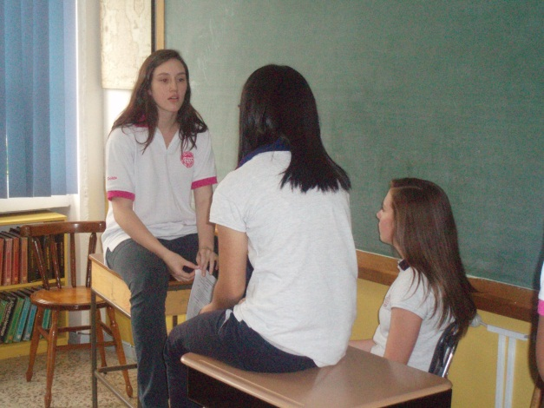
Students from the senior class participated in a High School wide initiative this week as they spent some individual mentoring time with the incoming freshmen. Beginning with an ice-breaker activity, they then went on to share their experiences and expertise to the freshmen in the hopes that this would help the 9th graders during this important time of transition. This week’s session was the first of four sessions that the seniors will have with their mentees in the coming month.
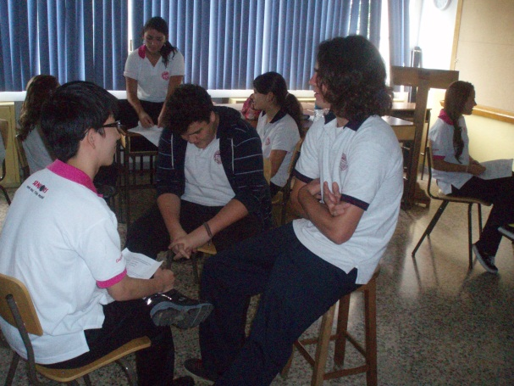
In preparing for the activity, the seniors participated in a training workshop during which they evaluated data from a survey given to the 8th and 9th grade students at the end of the year last year. In doing so, they determined what the greatest causes of anxiety might be for the students new to High School, how prepared the students felt they were, and what needs might be addressed. In their one-on-two sessions begun this week, they are addressing some of these needs, such as study and time management skills, managing stress, and finding a balance between academic and extra-curricular activities.
In reflecting on the first session, one of the seniors commented that their freshmen “are scared of some of the teachers in high school because they look very intimidating. They felt a lot better when they were reassured that most teachers were very nice once you got to know them.” He went on to note that he “taught them a strategy I recently acquired about studying and managing their time which they found to be very good.” Another senior observed that “there was great interaction between both sides, including lots of insightful questions from them. … They asked me a variety of questions ranging from academics to extracurricular activities all the way to parties and I was able to answer them all in a complete way. I was surprised to see that they weren´t scared to ask questions because I know I would´ve been scared if I were a freshman.” One of our senior girls explained that she “told them about the importance of school policies such as plagiarism because one is new and the other has been in CDS just one year.” Still another senior noted that “these kids are a blast to talk to and I look forward to meeting with them in future sessions.”
Studies indicate that the 8th grade – 9th grade transition is the most difficult period in a student’s career, with more students failing classes in the 9th grade than any other year. Last year, the CDS High School teachers made helping the 9th graders to succeed one of their highest priorities. Having the seniors help with this important goal in such a significant way has gone a long way to helping CDS High School be more welcoming and providing tools for success to its incoming freshmen.

